**Script for YouTube Video: Dependency Inversion Principle (DIP)**

**[Opening Sequence]**

[Show title screen with dynamic background music and the title: "Mastering the Dependency Inversion Principle in C#: Building Flexible and Decoupled Systems"]

**[Introduction]**

**Host**: "Hey everyone! Welcome back to [Your Channel Name]. In today’s video, we’re tackling the final principle in the SOLID series—the Dependency Inversion Principle, or DIP."

**Host**: "This principle is the backbone of building flexible, decoupled systems, and it’s crucial for scalable applications. We’ll explore what DIP is, its importance, and how to implement it in an HR Management System."

**Host**: "If you’ve been following our SOLID series, thank you for your support! Don’t forget to like, subscribe, and hit that bell icon for more developer tips and tutorials."

**[Part 1: What is the Dependency Inversion Principle?]**

**Host**: "The Dependency Inversion Principle focuses on reducing tight coupling between high-level modules and low-level modules by introducing abstractions."

[Display this definition on-screen.]

**Host**: "In simple terms, high-level modules should not depend on low-level modules. Both should depend on abstractions, such as interfaces."

**Host**: "It encourages designing systems where components are loosely coupled, making them easier to test, maintain, and extend."

**[Part 2: Real-Life Analogy]**

[Show a simple example of a plug-and-socket system.]

**Host**: "Let’s consider a plug-and-socket system. A phone charger doesn’t directly depend on the power source. Instead, both the charger and the wall socket follow a common standard—the plug interface."

**Host**: "This allows flexibility. You can plug in different devices, and the power source can remain the same."

**[Part 3: Example of Violating DIP]**

[Switch to Visual Studio or your preferred IDE.]

**Host**: "Let’s look at an HR Management System where we violate the Dependency Inversion Principle."

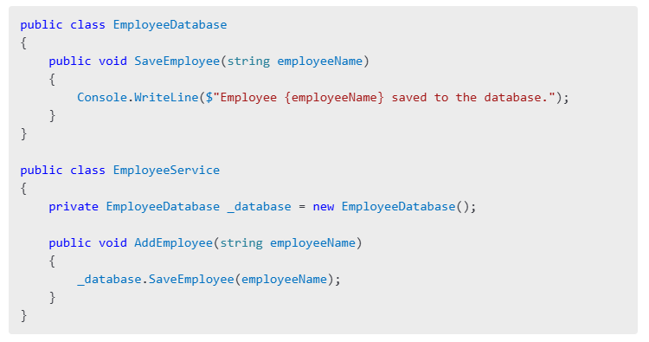

**Host**: "Here, EmployeeService directly depends on the EmployeeDatabase class. If we need to switch to another data storage method, such as a file system or cloud storage, we’d have to modify EmployeeService, violating the Open/Closed Principle as well."

**[Part 4: Refactoring to Follow DIP]**

**Host**: "To adhere to DIP, we introduce an abstraction—an interface—that both the EmployeeService and data storage implementations depend on."

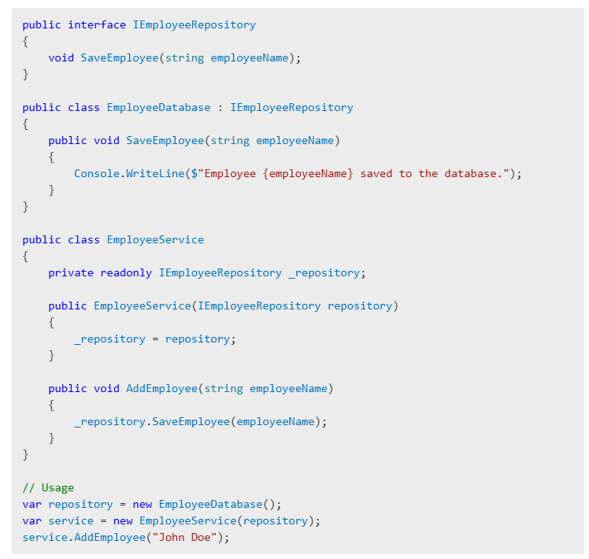**Host**: "Now, EmployeeService depends on the abstraction IEmployeeRepository. This makes it easy to swap out the implementation, such as using a file-based repository instead of a database."

**[Part 5: Advantages and Disadvantages of DIP]**

**Host**: "Let’s quickly discuss the pros and cons of following the Dependency Inversion Principle."

**Advantages**:

* "Promotes loose coupling between modules."
* "Facilitates better testability by allowing dependency injection."
* "Supports scalability and code reuse."

**Disadvantages**:

* "Can introduce additional complexity with too many interfaces."
* "Requires upfront design and planning."

**[Part 6: Best Practices for Implementing DIP]**

**Host**: "Here are some best practices for applying DIP in your projects."

1. "Identify dependencies that tightly couple your modules."
2. "Extract interfaces or abstract classes for those dependencies."
3. "Use dependency injection frameworks, such as .NET’s built-in DI or third-party tools like Autofac."

**[Part 7: Closing and Call-to-Action]**

**Host**: "To summarize, the Dependency Inversion Principle is about decoupling high-level and low-level modules by using abstractions. It ensures your code is more flexible, testable, and maintainable."

**Host**: "Have you applied the Dependency Inversion Principle in your projects? Share your experience in the comments below!"

**Host**: "If you found this video helpful, give it a thumbs up and subscribe to [Your Channel Name]. That wraps up our SOLID Principles series. Stay tuned for more deep dives into software design and development!"

[End with upbeat music and your channel logo.]

**[On-Screen Text Suggestions]**

1. "Key Takeaway: High-level and low-level modules should depend on abstractions."
2. "Best Practice: Use dependency injection to implement DIP."
3. "SOLID Principles Series: Watch the full playlist."

**Suggested B-Roll and Visuals**

1. **HR Management System**: Show visuals of an employee management dashboard.
2. **Animations**: Demonstrate the transition from tightly coupled modules to abstracted modules.
3. **Text Popups**: Highlight key points during the code walkthrough.

Let me know if further refinements or examples are needed!